FACULTY EVALUATION
Programme Name: Resource Mobilization Programme
Session: Resource Mobilization Strategy || Tools for Fundraising
Faculty Name: Leone Mawa
No. of Respondents: 11
No. of Participants: 11
Evaluation Parameter | (%) Individual Score | (%) Programme Average
Punctuality | 89 | 96
Clarity of presentation | 89 | 94
Degree of preparation | 89 | 94
Course design & org | 85 | 91
Content & methodology | 87 | 93
Quality of discussions | 87 | 94
Relevance to work | 91 | 95
Average scores | 88 | 94

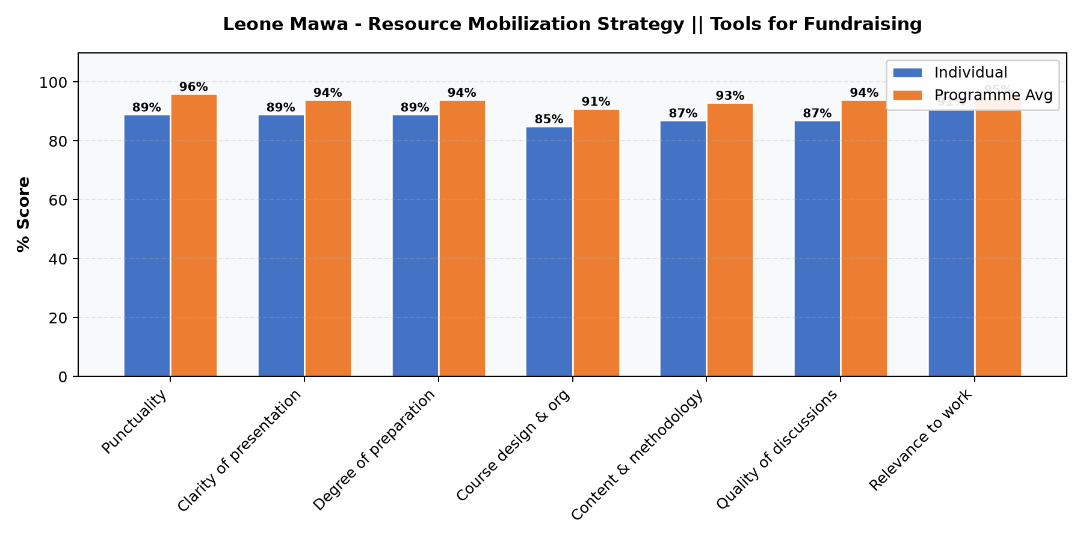

Comments & Feedback
- • The day seemed not well planned for. The afternoon session the faculty was tired and not well prepared
- • Alot of time is needed for this to help develop one for an organization.Consider allocating more time for this
- • Meet expectations
- • More time
- • Keep up
SUBMITTED THROUGH:
NAME: ______________________ SIGN: ______________________ DATE: ______________________

